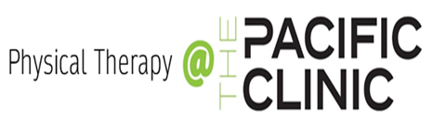
1350 North Grant Street Kennewick, WA 99336 Phone: (509) 735-2014 Fax: (509) 735-3980

PATIENTS NAME:
DATE OF BIRTH:
DATE OF ONSET:
DIAGNOSIS / ICD-10:

❑ EVALUATE & TREAT

❑ PHYSICAL THERAPY  MASSAGE THERAPY*
❑ AQUATIC THERAPY

FREQUENCY: __________________________ DURATION: __________________________

*FREQUENCY, DURATION AND DIAGNOSIS ARE REQUIRED FOR MASSAGE THERAPY

PRECAUTIONS / REMARKS:

Physical Therapist: __________________________________________________________ / ______________________
Signature Date

PHYSICIAN: _________________________________________________________________________
PRINT

_________________________________________________________ / ___________________

SIGNATURE DATE

